Experiment name : Write a simple matlab program to perform general procedure of Single side band modulation and demodulation .

Objective :

Objective is to perform Single side band modulation for a message signal and demodulate the signal and recover the message signal

code :

clc;

clear all;

ma=input('enter message amplitude: ');

ca=input('enetr carrier amplitude: ');

fm=input('enter messege frequency: ');

fc=input('enter carrier frequency: ');

t=0:0.001:1;

m1=ma\*sin(2\*pi\*fm\*t);

c1=ca\*sin(2\*pi\*fc\*t);

s1 = m1.\*cos(2\*pi\*fc\*t) + (hilbert(m1).\*sin(2\*pi\*fc\*t)); % upper

s2 = m1.\*cos(2\*pi\*fc\*t) -( hilbert(m1).\*sin(2\*pi\*fc\*t)); % lower

su=s1.\*c1;

sl=s2.\*c1;

subplot(7,1,1)

plot(t,m1,'k');

title('message signal');

subplot(7,1,2);

plot(t,c1,'b');

title('carrier signal');

subplot(7,1,3);

plot(t,su,'g');

title('SSB-SC upper modulation signal');

subplot(7,1,4);

plot(t,sl,'g');

title('SSB-SC lower modulation signal');

noise=randn(size(t));

subplot(7,1,5);

plot(t,noise,'r');

title('noise signal');

adnoise=s1+noise;

adnoise=adnoise.\*cos(2\*pi\*fc\*t);

wn=0.02;

[b,a]=butter(2,wn);

vout=filter(b,a,adnoise);

subplot(7,1,6);

plot(t,vout,'c');

title('upper demodulated signal');

adnoise1=s2+noise;

adnoise1=adnoise1.\*cos(2\*pi\*fc\*t);

wn=0.02;

[b,a]=butter(2,wn);

vout=filter(b,a,adnoise);

subplot(7,1,7);

plot(t,vout,'c');

title('lower demodulated signal');

output:

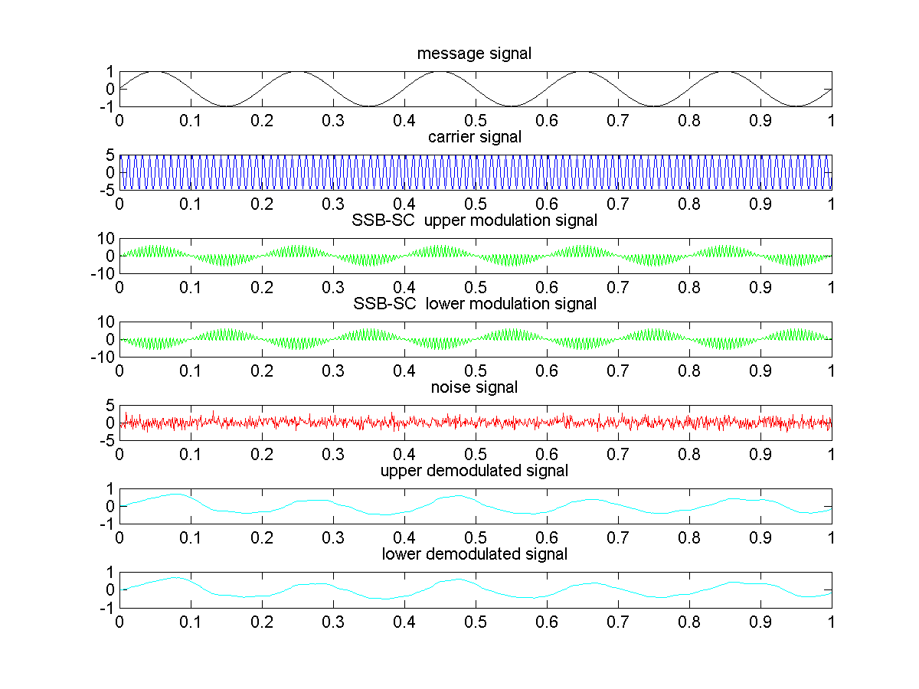

conclusion :

In this lab we learnt how to perform SSB modulation for a message signal using Hilbert transform .And recover the signal again or in other words demodulate the signal , we learnt the what noise is and how it effects on the output . This lab will be of great help in the upcoming labs .